Box Basics

Accessing Box via Web
Access Box by logging into http://my.pitt.edu/
Then, click on the Box link at the top of the page.
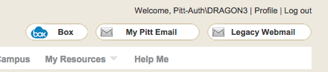

Accessing Box via Client
You can also access Box directly from your Mac or Windows machine by installing the client.
- Log into my.pitt.edu
- click on the following link: https://pitt.app.box.com/settings/sync
- Download Box Sync for Windows/Mac

Web vs. Client
The PC client makes accessing and manipulating the shared documents and folders very easy. For everyday use I would recommend using the client.
In order to change permissions, add collaborators, or view older versions of documents you must go through the web portal.

Adding Folders (via web):
- Log into Box via http://my.pitt.edu
- Click New
- Choose Folder
- Name folder
- Choose to keep it private or add collaborators (see below for permissions types).
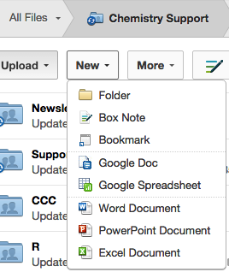
NOTE: adding folders via PC client works just like normal Mac or Windows folder creation.

How to Add Collaborators to an existing folder
- Go into box via http://my.pitt.edu
- Navigate and click on the folder in question
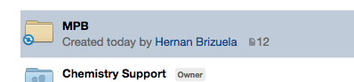

- Select Collaborators, found on the right side of page
- Click Invite People
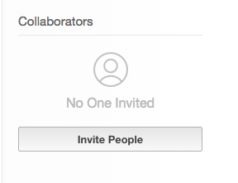
- Type in person’s last name or email address.
- Select appropriate address (NOTE: Box is tied into Pitt’s Global Address Book – thus all Pitt addresses should be present)
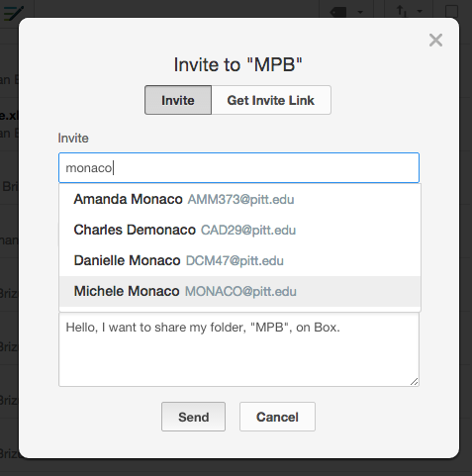
- Click Invited Permissions pull down menu and select appropriate permissions level
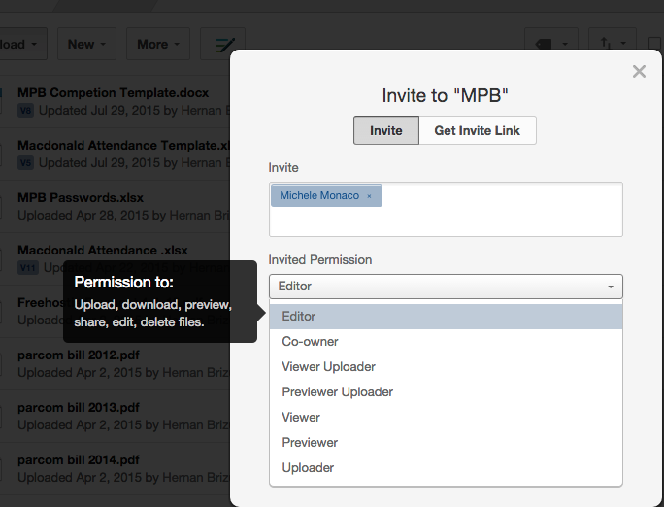
NOTE: Hovering over the permission type gives an overview of what is allowed.
(See Appendix for further clarification)
- Click Send

Folder Types

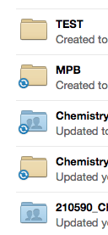
As you create, synchronize, and collaborate with people via the web client, you will notice that the folder icons will change depending on the situation.
A newly created folder from the web will look like the TEST folder (plain yellow folder).
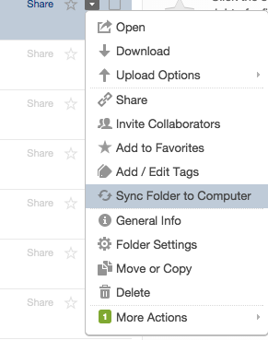
NOTE: If you also use the client, and create a folder on the web, by default it will not synchronize with your desktop client unless you choose the More Options pull down menu and choose Sync Folder To Computer.
A folder that is set to synchronize with your desktop machine looks like the MPB folder. It has the blue and white sync circle
If you invite collaborators it will look like the 210590 folder, displaying an outline of two people’s heads.
Orange sync circle (not shown) indicates that items are pending synchronization.

Version History

One of the nice features of Box is Version History. Every time you save the document, it gives it a new version number. You are able to go back and retrieve past versions. Box actively stores the last 10 revisions. It is still possible to go back even further. Retrieving past versions is done through the web.

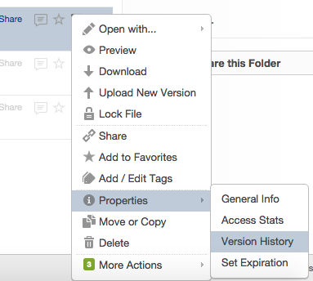
Restoring a Previous Version
- Log into Box via http://my.pitt.edu
- Go to file in question via Web
- Click More Options pull down menu
- Click Properties
- Select Version History
- Select version you wish to revert to: either download it or make it the “current version”.

Restoring Deleted Files/Folders
Box features a Trash that allows you to recover files and folders that have been deleted. By default, all deleted items will be moved from the Trash location of your account and will be purged after 30 days. This works when deleting from local PC client or from Web.
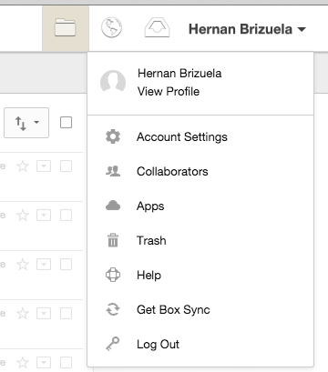
To restore:

- Click pull down menu next to your name.
- Click Trash
- Click the pull down menu next to the file you wish to restore
- Select Restore
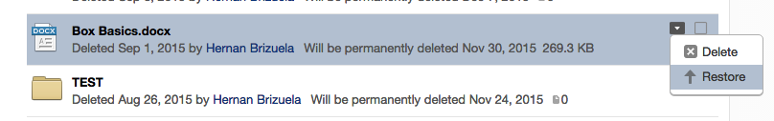

Opting Out of Shared Folders
As time goes on, you may notice your box folder start to get cluttered with folders that people have shared with you. If you no longer need to see the folder or collaborate, there is a way to remove yourself from the collaboration. The following housecleaning tip will help with organizing and keeping things manageable.
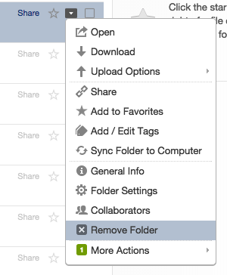
- Go to Box via the web (my.pitt.edu)
- Click on the More Options pull down menu on the folder in question.
- Select Remove Folder
- Select OK on confirmation box
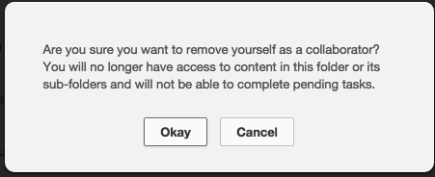
This will remove the folder and collaborating permissions for folders that were shared with you that you no longer wish to be a part of or need.

Notifications
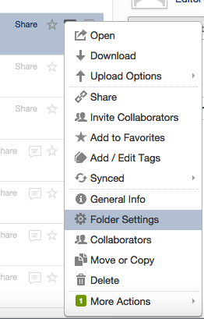
You can adjust what notifications you receive for shared folders:
- Go to the folder in Box over the Web
- Click on the More Options pull down menu
- Select Folder Settings
- Scroll down to Email and Notifications section
- Adjust the notification to your preference
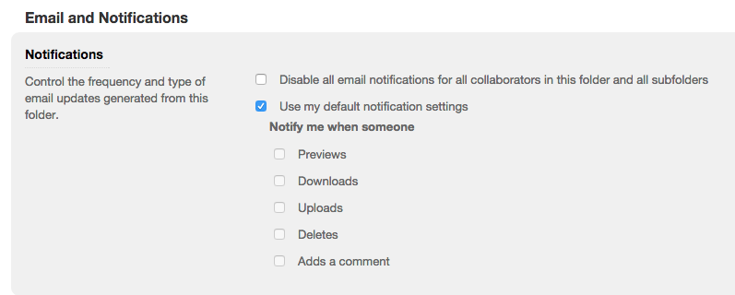

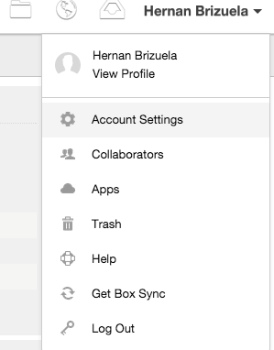
While the above option allows you to specify the amount of notification for a particular folder, you can also adjust the notifications you receive on a global level.

- Go to Box via the web (my.pitt.edu)
- Click on your profile pull down
- Choose Account Settings
- Click on the Notifications tab
- Make adjustments
- Save

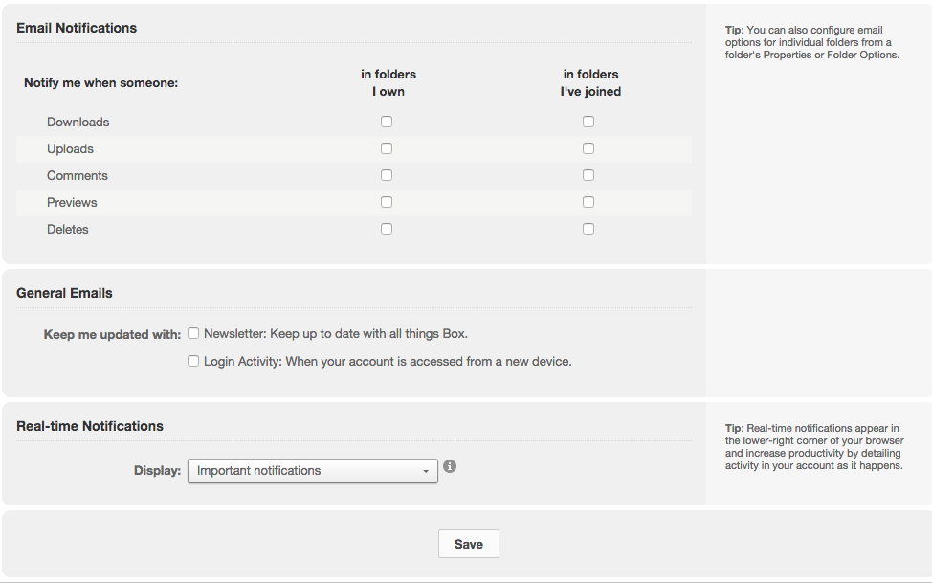
Appendix
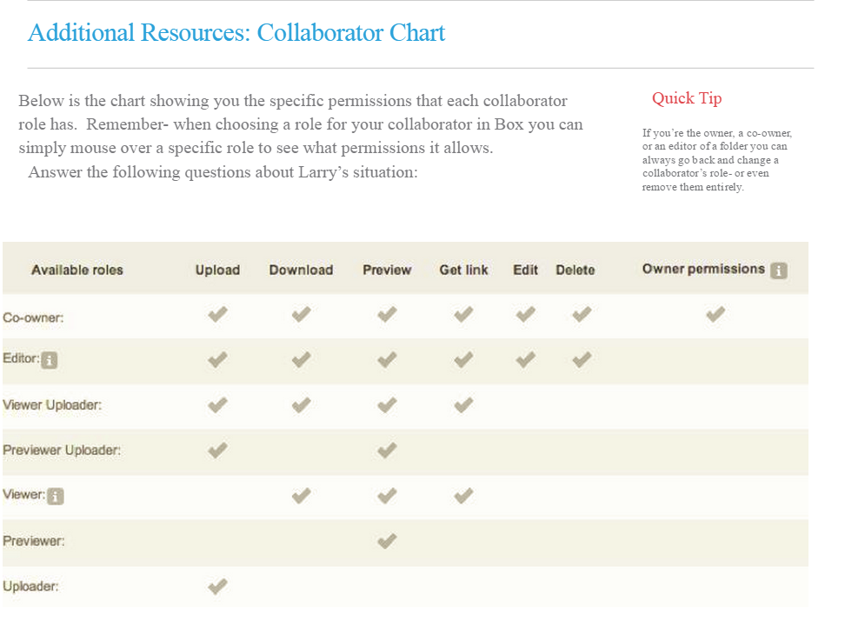

Share Link vs. Collaborators
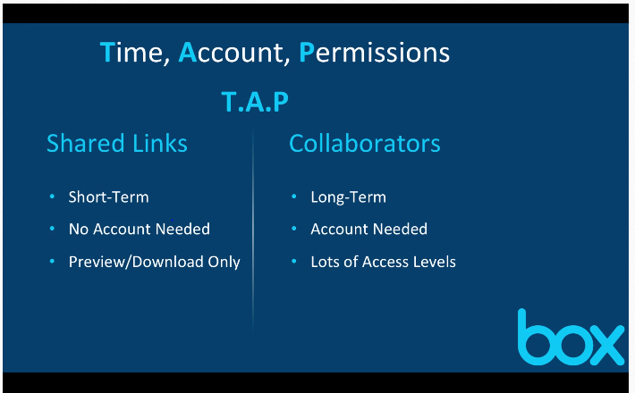
In general, you’d use a shared link for those who need a one off, short term access. For long term sharing, it is best to use the Collaborators option

